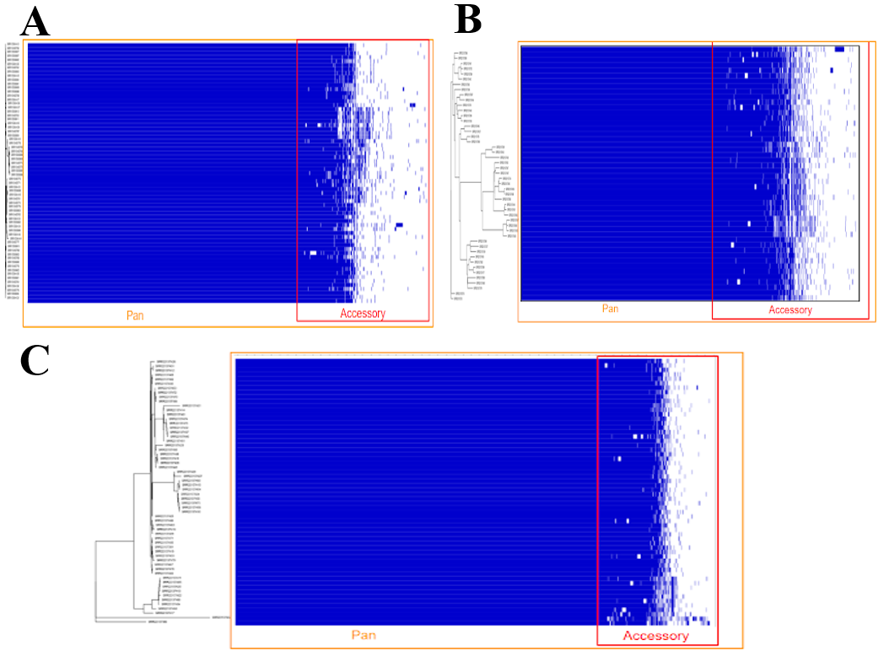
Supplementary figure 1 Gene presence-absence matrix generated by Phandango for MDR-TB isolates from (A) Arunachal Pradesh, (B) Odisha and (C) Sikkim

